1. Test for include miss. Result is right.  
   
2. Test for extend miss. Result is right.  
   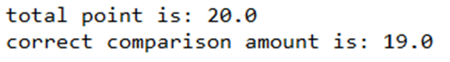
3. Test for actor and usecase name changed. Result is right.  
   
4. Test for generalization miss. Result is right.



1. Test for wrong association. Result is right.  
   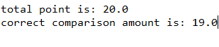
2. Test for use case miss. Result is right  
   
3. Test for actor miss. Result is right.  
   